**W E L C O M E**

**April 20, 2025**

**Happy Easter!**

Service Times: 9:00 & 10:45am

**The Proclamation of the Resurrection**

Kori Mauch | Sarah Cantrell | Taylor Hayward

Call to Worship

*Christ The Lord Is Risen Today*

*In Christ Alone*

Gospel Story | Terry Gin

*Living Hope*

*Agnus Dei (Refrain)*

*Christ Is Risen (Refrain)*

Pass the Peace

**Children's Programming:** 9am & 10:45am  
4 yrs. – 2nd grade, Room 8 | 3rd - 5th grade, Room 9

**Who Has the Keys?**

Revelation 1:17-18

**Pastor Jeff Knitt**

Communion

*Homecoming*

*Yes He Lives*

Benediction & Blessing



If standing is difficult or tiring for you, please feel

free to be seated at any point in our service.

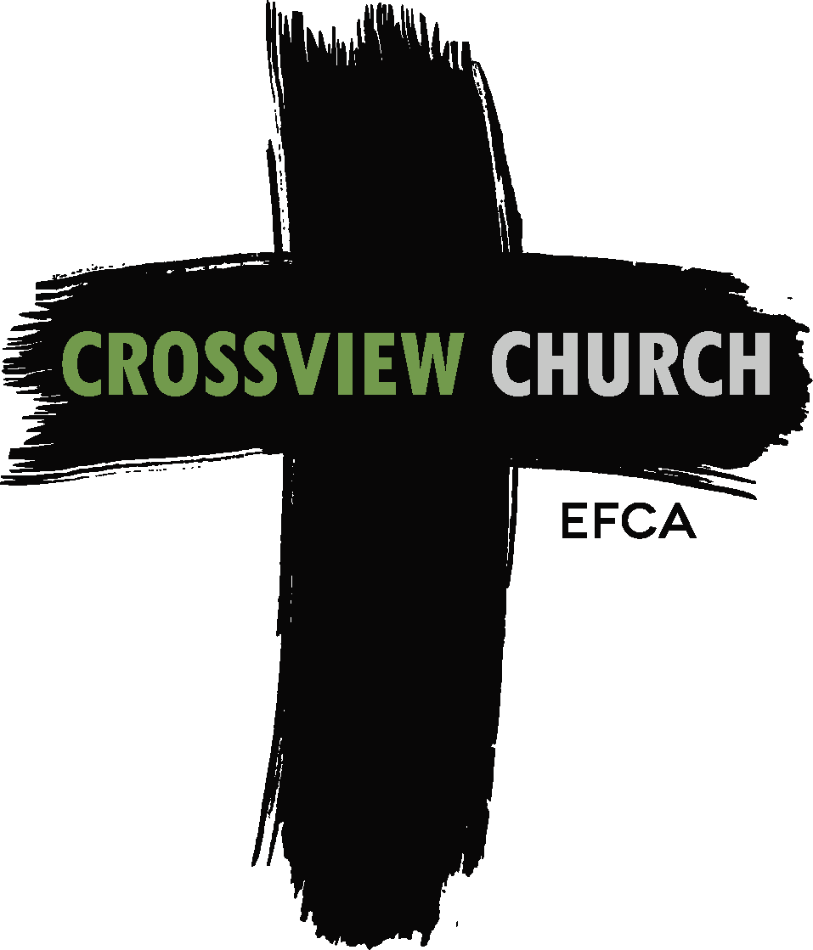

**SERMON NOTES**

**NEXT STEPS**

We want you to feel a part of our church community as we worship Jesus Christ together. Please tear off this form and place in the black box entitled “Prayer Requests and New Attendees” on the table as you exit the sanctuary. Thank you!

* First Time Visitor
* Regular Attendee
* Update My Information

Please take a moment to fill out this form:

Name: ___________________________

Address: ___________________________

___________________________________

Phone: ___________________________

E-mail: ___________________________

Family members attending with you:

___________________________________

___________________________________

I would like more information about:

* Baptism
* Membership
* Children’s Ministry
* Youth Ministry
* College Ministry
* Discipleship Groups
* Knowing more about Christ
* I would like to speak to a Pastor
* I would like to receive emails
* Other:

_______________________________

TODAY

**Nursery** Available both services.

**Children’s Programming** Available both services. Children are dismissed.  
                            4 yrs. – 2nd grade, Room 8   |   3rd – 5th grade, Room 9

**No HS Youth Group** Happy Easter!

WEEK AHEAD

**MEETINGS/EVENTS**

**Monday** 10:30am Women’s Prayer

Noon-3pm Library Team Meeting

**Wednesday** 6:30am Men’s Prayer

6-8pm MS Youth Group

**Thursday** 6:30pm Women’s Ministry Team Meeting

7-9pm Global Team Meeting

7pm Worship Rehearsal

**PRAYER REQUESTS**

**YOUTH GROUP: IMPORTANT –** Parents, please join our communication platform to instantly receive time/location changes & cancellations.

**HS Youth Group: *Text* @CviewH** to 81010.   
**MS Youth Group: *Text* @CviewM** to 81010.

Questions? Contact Nolan Hodge, Youth Pastor: **nhodge@crossviewefca.com**

**ANNOUNCEMENTS**

**PRAY FOR ONE ANOTHER** - Pray we will rejoice in our Risen Savior and Lord this week! Pray Philippians 4:4-9 for each other.

*How can we pray for you?* Tear off form and place in black box entitled “Prayer Requests and New Attendees” on the table as you exit the sanctuary or email them to: contact@crossviewefca.com.

|  |
| --- |
| **EASTER SUNDAY**  **Worship:** 9:00 & 10:45am | **Brunch:** 9:30 – 11:30am  **Easter Worship Playlist:** Go to [www.crossviewefca.com](http://www.crossviewefca.com); scroll down; click on  Easter Sunday Worship Music Playlist. |

**The Elders are requesting** that we hold another Congregational Meeting between services next Sunday, April 27 for the purpose of requesting approval to replace the fascia and soffit while we are replacing the roof. The additional cost is $21,400, but better to address it when replacing the roof.

**Crossview Commons** episodes are available by searching on Apple Podcasts, Spotify, YouTube, or anywhere you listen to podcasts. If you want to record an episode contact: [marklanting1@gmail.com](mailto:marklanting1@gmail.com).

**Stay Updated by joining our email list!**Go to: crossviewefca.com and scroll down to the green box that says, “Subscribe to our weekly email”. Fill in your email address and full name. Click the box next to “bulletin announcements” and then subscribe.

**New Membership Class**- Christine Abt, Christina Efstathiou, Sarah Graff, Kathy Moore, Lee & Deanna Sexton and Jason & Christine Wesbrock. Facilitators are Doug & Kathy Stice.

**Salvation Army Donations - Thank you for your yearlong** donations to the “Salvation Army Collection” bin in the lobby! They need paper products and plastic bags. Thank you!

**Electronic Donations:** Crossview will give you a charitable donation statement at the end of the year. For Electronic Fund Transfers contact Mary Campbell, Financial Secretary: 307.760.9810. Want to use a credit card - give online through our secure website: [www.crossviewefca.com/give/](http://www.crossviewefca.com/give/).

**Benevolent** **Donation** - designate this on the memo line of your check. Donations are greatly appreciated and will be used for those in need in our congregation.

**Please check** **books** out before removing them from the library. Thank you!

|  |  |
| --- | --- |
| **VBS Registration is OPEN for Participants and Volunteers!**This FREE event takes place June 9-12 from 6-8pm. Scan the QR code to register or go to: vbspro.events/p/cvtruenorth. Invitations are in the lobby. Kids, feel free to grab one and a couple extra for your friends! |  |

**Want to share your Jesus story?** Email Faith Ng at:[faithortiz2020@gmail.com](mailto:faithortiz2020@gmail.com)**.**

**CONNECT WITH CROSSVIEW CHURCH**

**DISCIPLESHIP GROUPS**For groups and times scan the QR code below, visit www.[crossviewefca.com/group-life/](http://www.crossviewefca.com/calendar) or see the bulletin board in the east hallway.

|  |  |  |  |  |  |
| --- | --- | --- | --- | --- | --- |
|  | **Current Discipleship Groups** |  | **View Church Calendar** |  | **Subscribe to our Weekly Emails** |

* Please keep my request confidential.
* I would like to talk confidentially with someone about my prayer request.

Senior Pastor *Jeff Knitt*

jknitt@crossviewefca.com

Children’s Ministry *Sarah Cantrell*

scantrell@crossviewefca.com

Worship Pastor *Stu Volz*svolz@crossviewefca.com

Youth Pastor *Nolan Hodge*

[nhodge@crossviewefca.com](mailto:nhodge@crossviewefca.com)

**Sunday Worship**

**9:00 & 10:45am**

150 Bethany Road | DeKalb, IL 60115

(815) 756-8729

contact@crossviewefca.com

facebook.com/crossviewefca  
instagram.com/crossviewefca

Office Hours: Monday Closed  
Tuesday – Friday 8:30am - 4:30pm